

**Tribhuvan University Faculty of Humanities and Social Science**

**A PROJECT REPORT ON**

**Online Book Store**

**Submitted to**

**Department of Computer Application**

**Birendra Multiple Campus**

***In partial fulfillment of the requirements for the Bachelors in Computer Application***

Submitted by

Name: Roshan Kumar kc

Roll no: 18…..8

Poush, 2078

Under the Supervision of

**_____**

Supervisor’s certificate

**Tribhuvan University**

**Faculty of Humanities and Social Science**

**College Name**

**Supervisor’s Recommendation**

I hereby recommend that this project prepared under my supervision by Roshan Kumar Kc entitled “**Online Book Store”** in partial fulfillment of the requirements for the degree of Bachelor of Computer Application is recommended for the final evaluation.

...........................

**______________**

Lecturer

BCA

Internal and External Examiner’s Approval

**Tribhuvan University**

**Faculty of Humanities and Social Science**

**College Name**

LETTER OF APPROVAL

This is to certify that this project prepared by Roshan Kumar kc Thapa entitled “**Online Book Store”** in partial fulfillment of the requirements for the degree of Bachelor in Computer Application has been evaluated. In our opinion it is satisfactory in the scope and quality as a project for the required degree.

|  |  |
| --- | --- |
| **…….……….……….……….…….**  **SIGNATURE of Supervisor**  Mr.Soba Raj Paudel  Department of Computer Application  Birendra Multiple Campus  Bharatpur-10,Chitwan | **…….……….……….……….…………**  **SIGNATURE of HOD/ Coordinator**  Mr.Soba Raj Paudel  Department of Computer Application  Birendra Multiple Campus  Bharatpur-10,Chitwan |
| **….……….……….……….……………**  **SIGNATURE of Internal Examiner**  **Internal Examiner** | **….……….……….……….……………**  **SIGNATURE of External Examiner**  **External Examiner** |

Abstract

Online Book Store is a web application where customer get there favorites collection of books, from where customer can order and pay through internet in ease.

The main objective of this project is to create an online book store that allows users to search and purchase a book online based on title, author and subject.

Simple process with interactive user interface viewing details of book with author name, descriptions of book, price tag, stock, reviews from other reader and much more. Moreover, user can add, delete, cancel Order and edit cart and can make review after reading Books.

A simple step to purchase, after registering account confirming email and then login and adding list of books in a cart. Moreover, providing details of user, where to deliver and payment using stripe account (credit card) .After purchase is done there will be a unique token forwarded to user via mail. Furthermore, Token will be added in database which help admin to identify where the books is to be delivered, how many books are listed by user, payments have been done or not and many other details they have listed while purchase. Moreover, User can cancel Order.

Acknowledgment

I would like to express my special thanks to Birendra Multiple Campus allowing me to having this project .Moreover, to express my special thanks of gratitude to our supervisor Mr. Soba Raj Paudel who gave me the golden opportunity to do this wonderful project on the topic **Online Book Store**, which also helped me in doing a lot of research and I came to know about so many new tools and technologies.

Furthermore, I would like to thank my family who provided me all the resources required to make this project

Table of content

1. Introduction 1

1.1 Introduction 1

1.2 Problem Statement 1

1.3 Objectives 1

1.4 Scope and Limitations 1

1.4.1 Scope 1

1.4.2 Limitations 2

1.5 Report Organization 3

2. Background Study and Literature Review 4

2.1 Background Study 4

2.2 Literature Review 4

3. System Analysis and Design 5

3.1 System Analysis 5

3.1.1 Requirement Analysis 5

3.1.2 Feasibility Analysis 6

3.1.3 Data Modelling (ER-Diagram) 10

3.1.4 Process modelling (DFD) 11

3.2 System Design 13

3.2.1 Architectural Design 14

3.2.2 Database Schema Design 14

3.2.3 Interface Design (UI Interface / Interface Structure Diagrams) 21

3.2.4 Physical DFD 37

4. Implementation and Testing 39

4.1 Implementation 39

4.1.1 Tools Used (CASE tools, Programming languages, Database platforms) 39

4.1.2 Implementation Details of Modules (Description of procedures/functions) 39

4.2 Testing 40

4.2.1 Test Cases for Unit Testing 40

4.2.2 Test Cases for System Testing 41

5. Conclusion and Future Recommendations 54

5.1 Lesson Learnt / Outcome 54

5.2 Conclusion 54

5.3 Future Recommendations 55

List of figures

Figure 3‑1 Use-Case Diagram 6

Figure 3‑2 Gantt chart 9

Figure 3‑3 ER-Diagram of Online Book Store 10

Figure 3‑4 DFD Level-0 of Online Book Store 11

Figure 3‑5 DFD Level-1 Online Books Store 12

Figure 3‑6 System-Design of Online Book Store 14

Figure 3‑7 Books Database 15

Figure 3‑8 Signup-User-Table 15

Figure 3‑9 Admin-User-Cart Details Database 16

Figure 3‑10 Admin Login 21

Figure 3‑11 Admin Insert Book Details 22

Figure 3‑12 Books Details in Admin panel 23

Figure 3‑13 Update Details Admin Panel 23

Figure 3‑14 Delete Book Details 24

Figure 3‑15 Reviews Information’s 24

Figure 3‑16 Details Review Information’s 24

Figure 3‑17 Ordered Book List 25

Figure 3‑18 Admin Password Reset 26

Figure 3‑19 User Register Form 27

Figure 3‑20 User login Interface 27

Figure 3‑21 Register Email confirmation 28

Figure 3‑22 User Interface 28

Figure 3‑23 User Interface Book Details 29

Figure 3‑24 Books Reviews 30

Figure 3‑25 User Dashboard 31

Figure 3‑26 User Cart 32

Figure 3‑27 Payout from Cart 32

Figure 3‑28 User Reset Password 33

Figure 3‑29 Contact Form 34

Figure 3‑30 Token Mail to User 34

Figure 3‑31 Order Cancel 35

Figure 3‑32 Track-Order 35

Figure 3‑33 Change E-Mail 36

Figure 3‑34 Physical DFD – Admin Panel 37

Figure 3‑35 Physical DFD-User Interaction 38

List of tables

Table 3‑1 Admin Table 16

Table 3‑2 Book Table 17

Table 3‑3 Book Details More 17

Table 3‑4 User Table 17

Table 3‑5 User Profile 18

Table 3‑6 Mail change 18

Table 3‑7 User Cart 18

Table 3‑8 Password Reset 19

Table 3‑9 Email Registration Verification Table 19

Table 3‑10 Book Reviews Table 19

Table 3‑11 User Delivery Table 20

Table 4‑1 Admin login test 42

Table 4‑2 Admin Password reset via email 43

Table 4‑3 User Password reset via email 44

Table 4‑4 Insert Books Details by admin 45

Table 4‑5 Registration of User with valid email 46

Table 4‑6 User login 47

Table 4‑7 Changing E-mail 48

Table 4‑8 Password change 49

Table 4‑9 Add Bio by user 50

Table 4‑10 Add to cart 51

Table 4‑11 Reviews of product after login 52

Table 4‑12 User Payment 53

**List of Abbreviations**

CSS : Cascading Style Sheets 8

DFD : Data-flow diagrams 11, 12

ER : Entity Relationship 10

GB : GigaByte 7

GHZ : gigahertz 7

HTML : Hypertext Markup Language 8

ISBN : International Standard Book Number 13, 45

MySQL : My Structured Query Language 8, 41

PHP : Hypertext Preprocessor 8, 41

RAM : Random Access Memory 7

# Introduction

## Introduction

An ecommerce website is an information technology method in which distributor can sell products and the customer can purchase on that website electronically by using internet from mobile or computer [1].

The primary goal of this e-commerce site is to sell books and services online and the project deals with developing an e-commerce website. For Online Book Sale, it provides the user with a catalog of different books available for purchase in store. Easy delivery in hand via any electronic device just by creating account. With just few simple steps paying using credit card makes steps even simple for user.

General speaking, an online Book store is design to eliminate the consumption of time taken by user to get Favorite Book of their choice going through store to store.

## Problem Statement

This Implementation will have several problem.

* Analyzing many Websites I came into conclusion Websites didn’t consider review as Priority Fact and it’s not true at all. Ex, when i buy books from any website first I check reviews of book to confirm this book is for me or not.
* Unfortunately buying a Hardcopy in Nepal via websites in rural is quite Hard.

## Objectives

This project will be conducted to fulfill following major objectives.

* To increase efficiency and improve services provided to the customers through better application of technology.
* It is designed to increase efficiency, save money and time.
* To avoid long queues at the counter.
* It shows the correct category and enable the customers to order items that are available.

## Scope and Limitations

### Scope

* Understand and prepare detailed requirement and specifications
* Prepare detailed design specifications of the system
* Develop the system and coding
* Demonstrate a bug free application after suitable modification if needed

### Limitations

* As the schedule for website is 24/7.However, for contact may delay.
* In case of customer Token leaked, illegal access of book can be made. Identity theft via token could be done.
* In order to get the whole ecommerce and delivery process right, a specialized workforce is required. To get these work done good amount of money will be shed first.
* Underdeveloped transportation infrastructure resulting in slow and uncertain delivery of Books.

## Report Organization

Reading the report from introduction to conclusion is quite tedious task therefore, I came forward to write in short and yet fast way to describe from designing, analysis with proper implementation and lastly conclusion.

Firstly, for System Analysis and Design gone thoroughly from what kind of approach and design I have used by showing via screenshot and Table. Moreover, the user register and login using an easy step and also the requirement that website need to run is of minimal cost. There are also the structure of database design which will help system admin to see how data will be passed from one component to another which is very handy.

Secondly, In case of Implementing and testing while designing the ER, DFD and other figure I mostly used creatly and visual-paradigm tool which was an online tool that will provide a free drawing using Browser with easy interface. There was two phase unit and system testing, where unit testing was conducted for five module for admin while inserting data, User module consist of getting account by verifying valid email with valid token. After successful login getting products details with cover picture , price ,description and price including reviews of users, cart of the user with update, edit and delete feature, the profile module where user can upload profile picture and change password. If some user tend to forgot there password then they can reset password requesting new from email. Finally, the payment module where users fill-up the forms such as locations, email, number and more with valid credit card. Which I is later forwarded to admin to verify the details before hand over the materials

Finally, conclusion with how this website could change the perspective of selling and buying Books from physical store to digital store How this come handy in first place and what kind feature this website lack which can be added later so, the website will function better than previous version.

# Background Study and Literature Review

## Background Study

The main objective of “**Online Book Store**” is to provide an essence of online book store via a simple and yet powerful medium.

Online shopping allows you to browse through endless possibilities, and even offers merchandise that's unavailable in stores. If you're searching for a nice Book that may not be distributed locally, you're sure to find what you're looking for on the internet.

What's even more useful from this website is the ability to read reviews which is written by a valid reader in first place, before buying it. You can search through multiple tab at the same time seeing price, description and reviews simultaneously eventually saving hours going through stores. Moreover, when you stood in line waiting, and waiting, and waiting to some other guy pay to the store staff and finally check out your items. Here, Online transactions comes in handy which occur instantly-saving you time to get your other errands done.

## Literature Review

There will be a lot of websites if we google Online Book store for all around the globe. However, what interesting is Nepal lack such facilities for providing Book because of trust issue or because implementing such business will be hard in sense of money and empowerment. Furthermore, while doing some small research in my own university and other couple of store and going through it I came into conclusion mostly the work is done manually and this implies to every Book store and university of Nepal. Moreover, there are couple of websites do provides this kind of facility but they lack the features that this website solely provide [2].

For Instance, Firstly, Logged in after registration, adding Book into cart after observing reviews from legitimate user. Secondly adding it into cart and make payment. Finally, with secure Token get the Book you ordered in any geographical reason. A simple step but a Crucial result.

# **System Analysis and Design**

## System Analysis

I used the Waterfall methodology while building this application. This project had fixed specification, ample time and enough resources so Waterfall methodology was used to build this system.

I was working with a fixed requirement so i created fixed milestones and deadlines. Waterfall methodology fitted perfectly with those requirements.

### Requirement Analysis

It is the process of defining the expectations of the users for an application that is to be built or modified. It needed to fulfill functional and non-functional requirement.

#### Functional Requirement

Functional requirements define the capabilities and functions that a system must be able to perform successfully. The functional requirements of this book ordering system include [3].

* The system shall enable the customer to view the products category, create an account, login to the system and place an order and cancel.
* The system shall provide user to add Nickname, Profile Image, Bio and change E-mail and password via confirmation E-mail
* The customer shall specify where order is to be delivered.
* The system shall display the book items ordered, the individual book item prices and the payment amount calculated.
* User shall provide credit cards details and purchase Books and get E-mail.
* The system shall provide visual confirmation of the order placement.
* The system shall enable the admin to view, create, edit and delete book category and descriptions.
* The system shall allow the admin to update additional information (description, cover Page, category, author and stock etc.) for a given book item.
* The system shall allow the admin to update price for a given book item.
* The system shall allow admin to cancel order and revoke stock and delete order.
* Keeping records of registration of customers.
* The system shall allow admin to change password via E-mail confirmation.
* The system shall alert user if Book order is canceled.

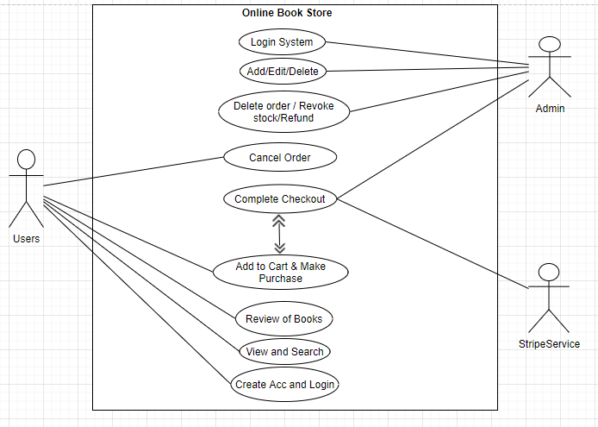

Figure 3‑1 Use-Case Diagram

#### Non Functional Requirement

A non-functional requirement is a requirement that specifies criteria that can be used to judge the operation of a system, rather than specific behaviors. Some of the non-functional requirements include [3]:

* Maintainability- easy to maintain
* Performance/ response time- fast response
* Usability by target user community- easy to use
* Safety- should be safe to use
* 24 X 7 availability

### Feasibility Analysis

A feasibility study is a test of a system proposal. According to its workability, impacts on the organization, ability to meet user needs and effective use of the resources its main task done during feasibility study are [4].

#### **Technical Feasibility**

This project will be focused on gaining an understanding of the present technical resources of the organization and their applicability to the expected needs of the proposed system. It is an evaluation of the hardware and software and how it meets the needs of the proposed system. The systems project is considered technically feasible if the internal technical capability is sufficient to support the project requirements.

**Software Requirements:**

Operating system: Windows XP / windows 7

Server: Apache 2.4.4

Front-end: PHP 5.4.19 (Framework: Bootstrap)

Back-end: MySQL 5.5.32(using PHPMyAdmin 4.0.6)

We have used XAMPP which is a free and Open Source Cross-Platform Web Server

Solution Stack. It comes with Apache Web Server, MySQL Database and PHP.

**Hardware requirements:**

Processor: Intel dual core or above

Processor Speed: 1.0GHZ or above

RAM: 1 GB RAM or above

Hard Disk: 20 GB hard disk or above

#### **Economic Feasibility**

Development of this application is highly economically feasible. The organization need not spend much money for the development of the system already available. The only thing is to be done is making an environment for the development.

#### **Operational Feasibility**

The system is operational feasible since the user are familiar with the technologies and hence there is no need to gear up the personnel to use the system. Also the system is very user friendly and easy to use

* Front-end

1. HTML
2. CSS
3. JavaScript

* Server

1. PHP
2. Xampp (apache)

* Back end

1. MySQL
2. Bash

* Framework

1. Bootstrap Framework
2. Ajax

* Library

1. jQuery

#### **Schedule Feasibility**

Proposed system would be designed as per the time calculated. Likelihood that timeframes can be met and that this adequate to meet organization's needs.

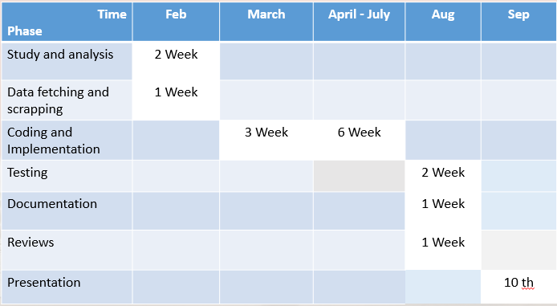

Figure 3‑2 Gantt chart

### Data Modelling (ER-Diagram)

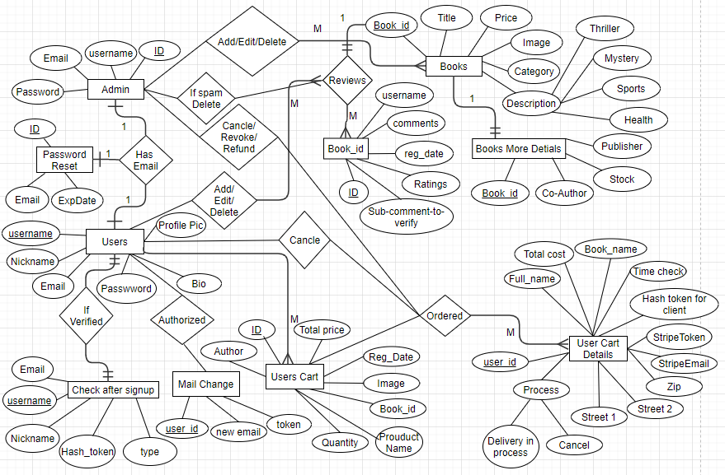

Figure 3‑3 ER-Diagram of Online Book Store

### Process modelling (DFD)

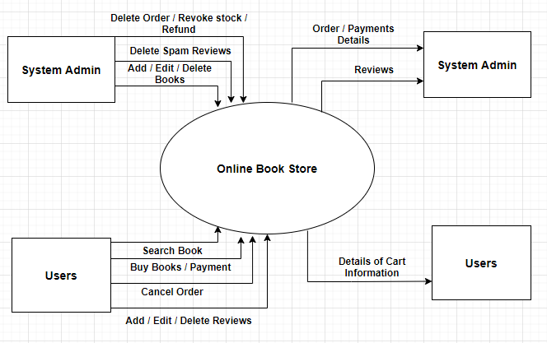

Figure 3‑4 DFD Level-0 of Online Book Store

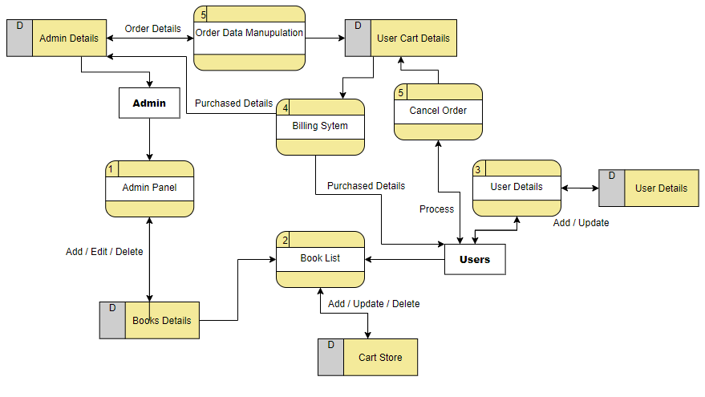

Figure 3‑5 DFD Level-1 Online Books Store

## System Design

System design represent the overall concept on how the system works. In our system there are two modules. They are system module and admin module [5].

**User Module:**

* Only register user can login into the application.
* Those users who are not register must register first by filling the necessary attributes such as name, email, password with verification etc. and then the account will be created by providing user name and password.
* User can read the name, Author name, Description and price of Books.
* User can also review Books which will be filter by admin and can read Reviews of other users.
* User can place Order and can cancel it.

**Admin Module:**

* Admin can Add, Edit and update Books with Author name, Title, Description, Stock and price using ISBN number.
* Admin can take down reviews if they are spam.
* Admin can verify Client who ordered Book with all details such as location, payment etc. by Token provided to user.
* Admin Can revoke the stock, cancel the order and refund.

### Architectural Design



Figure 3‑6 System-Design of Online Book Store

### Database Schema Design

The general theme behind a database is to handle information as an integrated whole. A database is a collection of inter-related data stored with minimum redundancy to serve single users quickly and efficiently. The general objective is to make information necessary, quick, inexpensive and flexible for the user.

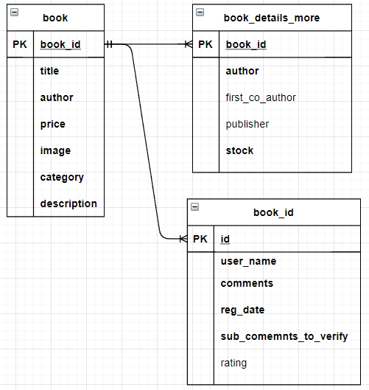

Figure 3‑7 Books Database

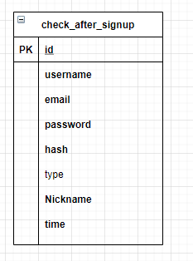

Figure 3‑8 Signup-User-Table

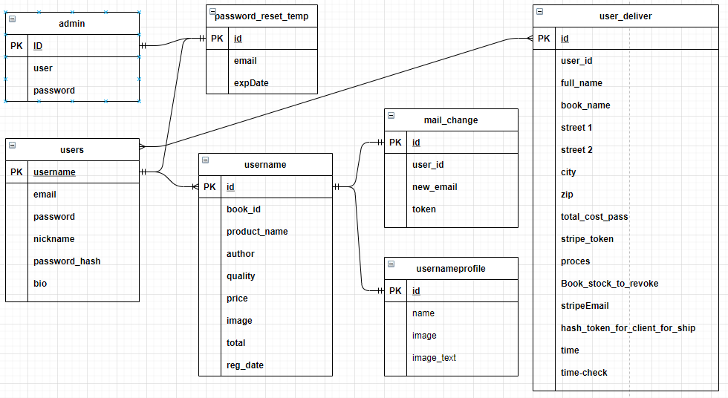

Figure 3‑9 Admin-User-Cart Details Database

#### Database Tables:

Table 3‑1 Admin Table

|  |  |  |  |  |
| --- | --- | --- | --- | --- |
| Field Name | Data Type | Size | Allow NULL | Constrain |
| ID | Int | 6 | Not | PK |
| Username | Varchar | 30 | Not |  |
| Password | Varchar | 30 | Not |  |

Table 3‑2 Book Table

|  |  |  |  |  |
| --- | --- | --- | --- | --- |
| Field Name | Data Type | Size | Allow NULL | Constrain |
| Book ID | Int | 6 | Not | PK |
| Title | Varchar | 50 | Not |  |
| Author | Varchar | 50 | Not |  |
| Price | Int | 30 | Not |  |
| Image | Varchar | 100 | Not |  |
| Category | Varchar | 50 | Not |  |
| Description | Varchar | 900 | Not |  |

Table 3‑3 Book Details More

|  |  |  |  |  |
| --- | --- | --- | --- | --- |
| Field Name | Data Type | Size | Allow NULL | Constrain |
| Book_id | Int | 100 | Not | PK |
| Author | Varchar | 100 | Not |  |
| First co author | Varchar | 300 | Yes |  |
| Publisher | Varchar | 300 | Yes |  |
| Stock | Int | 100 | Not |  |

Table 3‑4 User Table

|  |  |  |  |  |
| --- | --- | --- | --- | --- |
| Field Name | Data Type | Size | Allow NULL | Constrain |
| Id | Int | 6 | Not | PK |
| Username | Varchar | 30 | Not |  |
| Email | Varchar | 30 | Not |  |
| Password | Varchar | 30 | Not |  |
| Nickname | Varchar | 50 | Not |  |
| Bio | Varchar | 50 | Yes |  |

Table 3‑5 User Profile

|  |  |  |  |  |
| --- | --- | --- | --- | --- |
| Field Name | Data Type | Size | Allow NULL | Constrain |
| Id | Int | 6 | Not | PK |
| Name | Varchar | 30 | Not |  |
| Profile pic | Varchar | 30 | Yes |  |

Table 3‑6 Mail change

|  |  |  |  |  |
| --- | --- | --- | --- | --- |
| Field Name | Data Type | Size | Allow NULL | Constrain |
| ID | Int | 6 | Not | PK |
| User_id | Varchar | 30 | Not |  |
| New_Email | Varchar | 50 | Not |  |
| Token | Varchar | 400 |  |  |

Table 3‑7 User Cart

|  |  |  |  |  |
| --- | --- | --- | --- | --- |
| Field Name | Data Type | Size | Allow NULL | Constrain |
| Cart Id | Int | 6 | Not | PK |
| Book id | Varchar | 30 | Not |  |
| Product Name | Varchar | 30 | Not |  |
| Author | Varchar | 30 | Not |  |
| Quantity | Varchar | 30 | Not |  |
| Price | Int | 50 | Not |  |
| Image | Varchar | 50 | Not |  |
| Total | Int | 30 | Not |  |
| Register Date | Timestamp |  |  |  |

Table 3‑8 Password Reset

|  |  |  |  |  |
| --- | --- | --- | --- | --- |
| Field Name | Data Type | Size | Allow NULL | Constrain |
| Id | Int | 6 | Not | PK |
| Email | Varchar | 30 | Not |  |
| ExpDate | Varchar | 30 | Not |  |

Table 3‑9 Email Registration Verification Table

|  |  |  |  |  |
| --- | --- | --- | --- | --- |
| Field Name | Data Type | Size | Allow NULL | Constrain |
| Id | Int | 6 | Not | PK |
| Username | Varchar | 30 | Not |  |
| Email | Varchar | 30 | Not |  |
| Password | Varchar | 30 | Not |  |
| Hash | Varchar | 50 | Not |  |
| Nickname | Varchar | 50 | Not |  |
| Time | Timestamp |  |  |  |

Table 3‑10 Book Reviews Table

|  |  |  |  |  |
| --- | --- | --- | --- | --- |
| Field Name | Data Type | Size | Allow NULL | Constrain |
| Id | Int | 6 | Not | PK |
| Username | Varchar | 30 | Not |  |
| Comments | Varchar | 400 | Not |  |
| Register Date | Timestamp |  |  |  |
| Sub comment to verify | Varchar | 400 | Not |  |

Table 3‑11 User Delivery Table

|  |  |  |  |  |
| --- | --- | --- | --- | --- |
| Field Name | Data Type | Size | Allow NULL | Constrain |
| Id | Int | 6 | Not | PK |
| Full name | Varchar | 30 | Not |  |
| Book Names | Varchar | 6000 | Not |  |
| User Id | Varchar | 30 | Not |  |
| Street 1 | Varchar | 30 | Not |  |
| Street 2 | Varchar | 50 | Not |  |
| City | Varchar | 50 | Not |  |
| Zip | Varchar | 50 | Not |  |
| Total price | Int | 50 | Not |  |
| Stripe Token | Varchar | 50 | Not |  |
| Process | Varchar | 30 | Not |  |
| Book stock to revoke | Varchar | 30 | Not |  |
| Stripe Email | Varchar | 50 | Not |  |
| Hash token for Client to ship | Varchar | 50 | Not |  |
| Time | Timestamp |  |  |  |

### Interface Design (UI Interface / Interface Structure Diagrams)

All the interface used in my project.

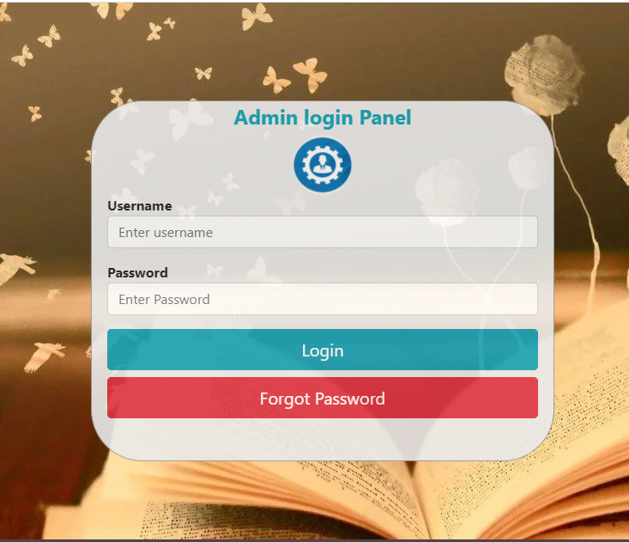

Figure 3‑10 Admin Login

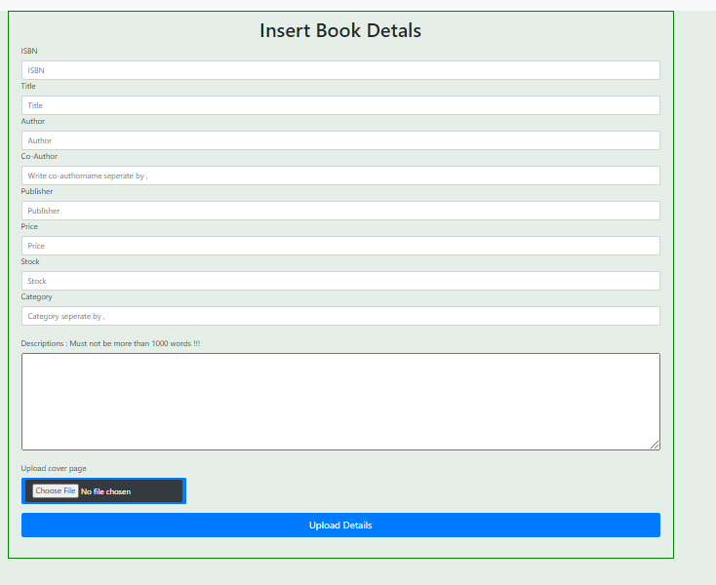

Figure 3‑11 Admin Insert Book Details

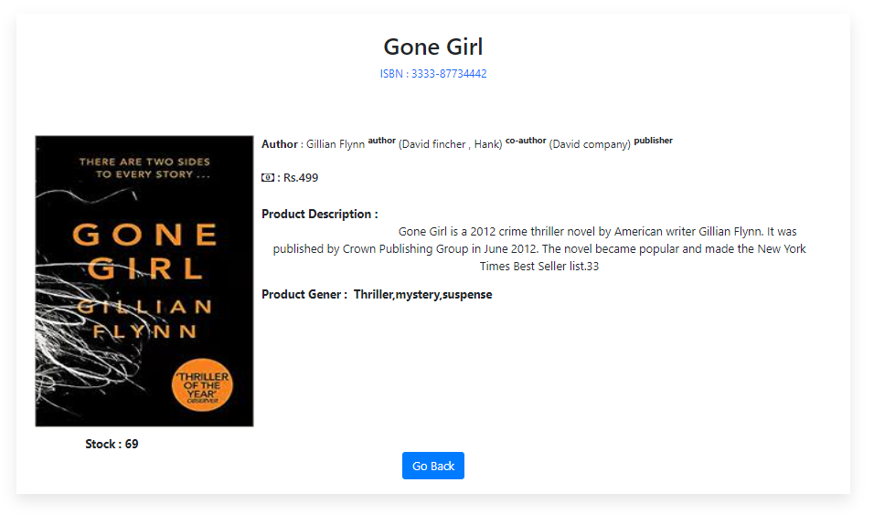

Figure 3‑12 Books Details in Admin panel

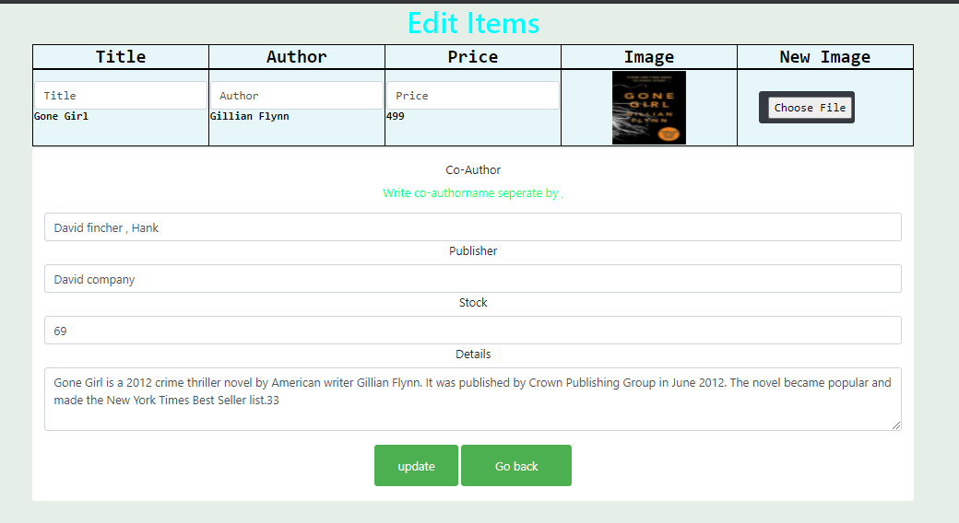

Figure 3‑13 Update Details Admin Panel

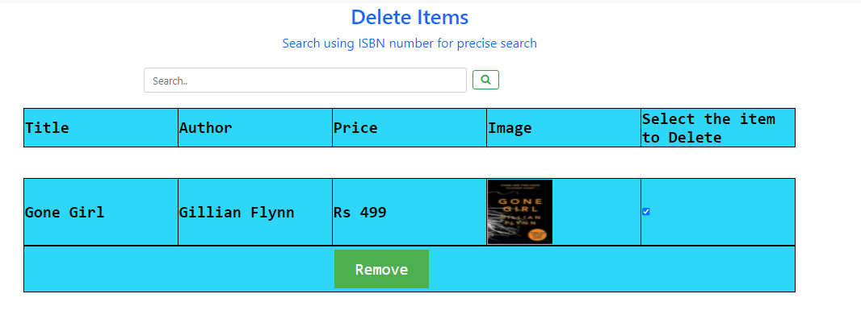

Figure 3‑14 Delete Book Details



Figure 3‑15 Reviews Information’s

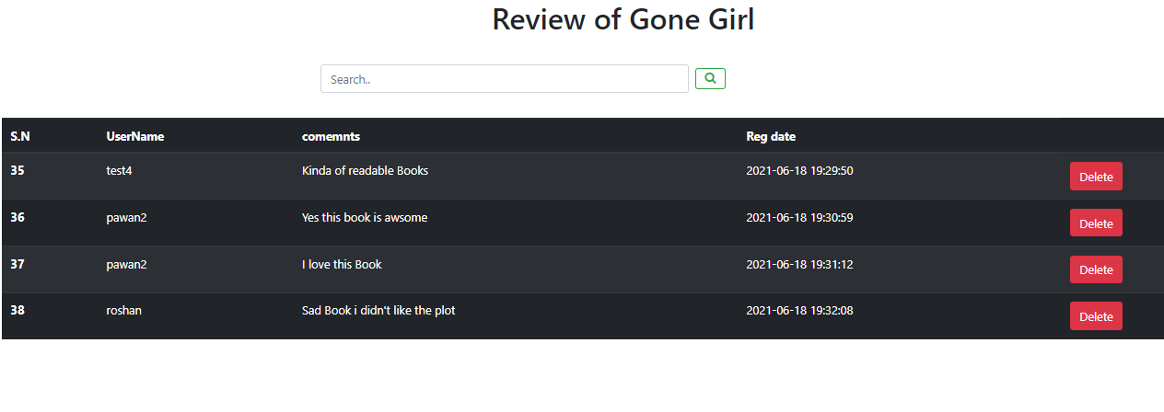

Figure 3‑16 Details Review Information’s

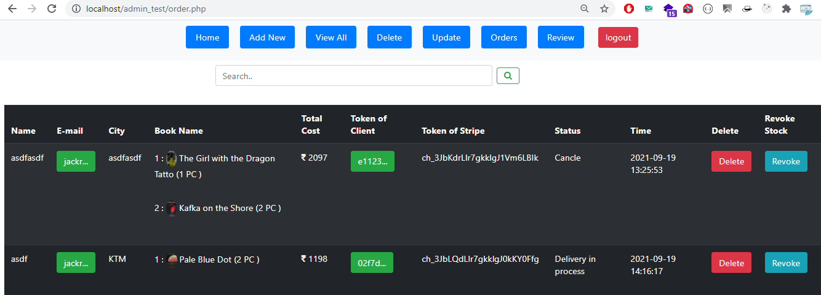

Figure 3‑17 Ordered Book List

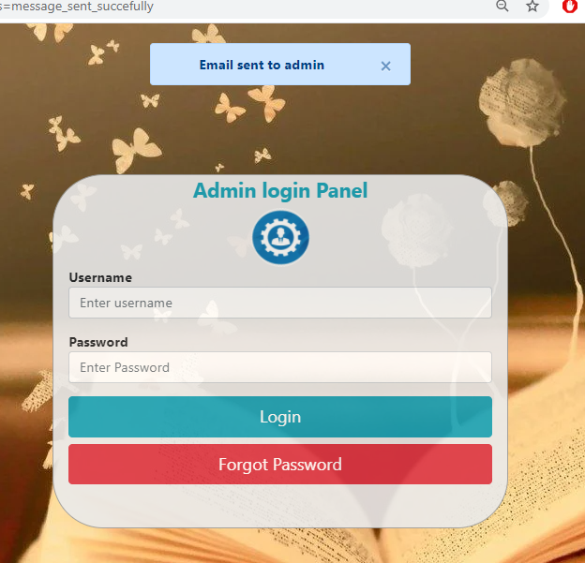

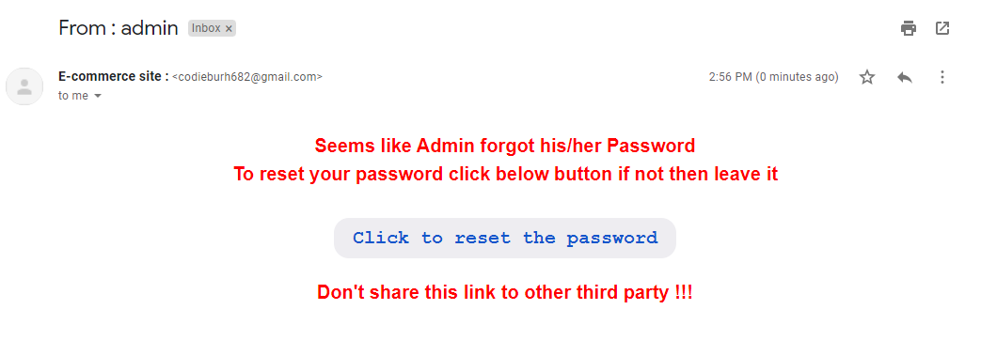

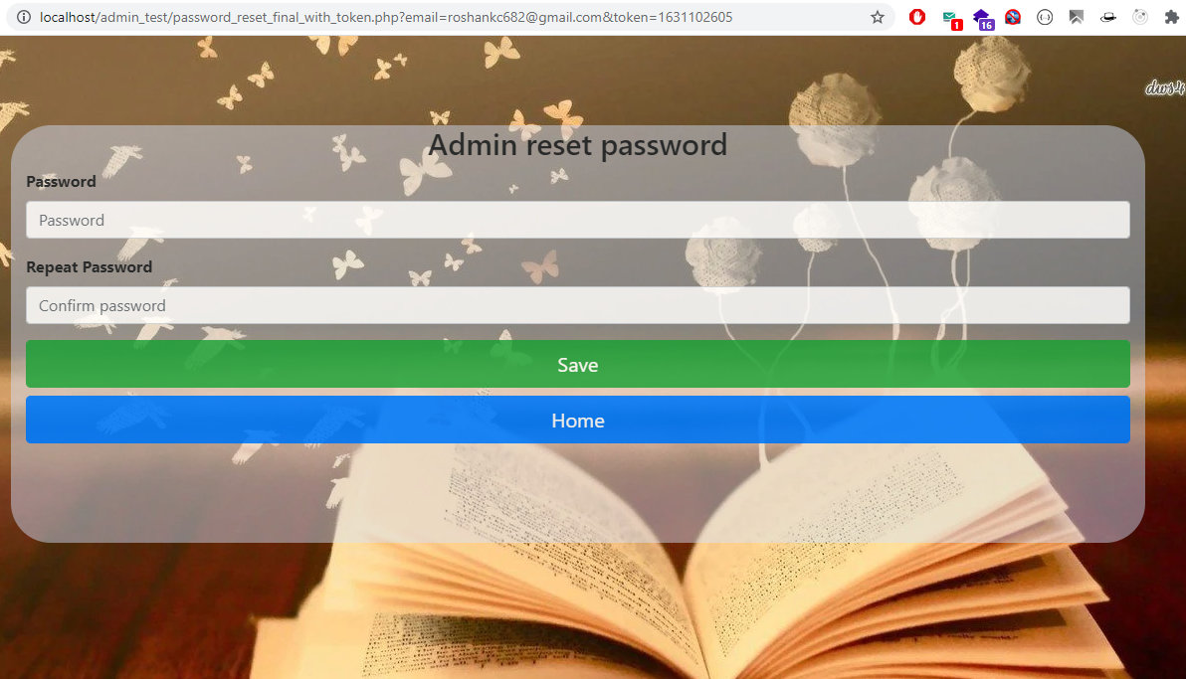

Figure 3‑18 Admin Password Reset

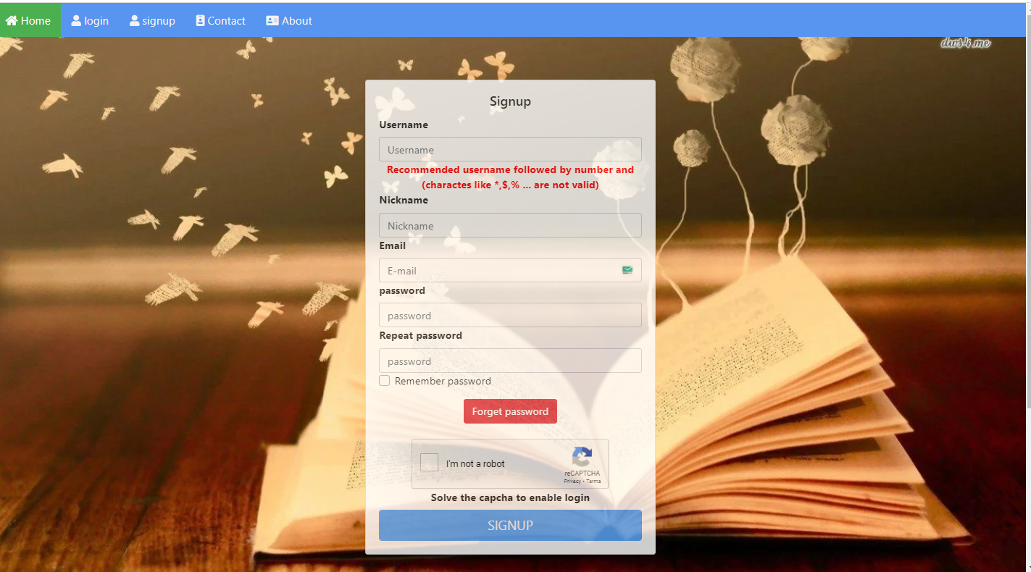

Figure 3‑19 User Register Form

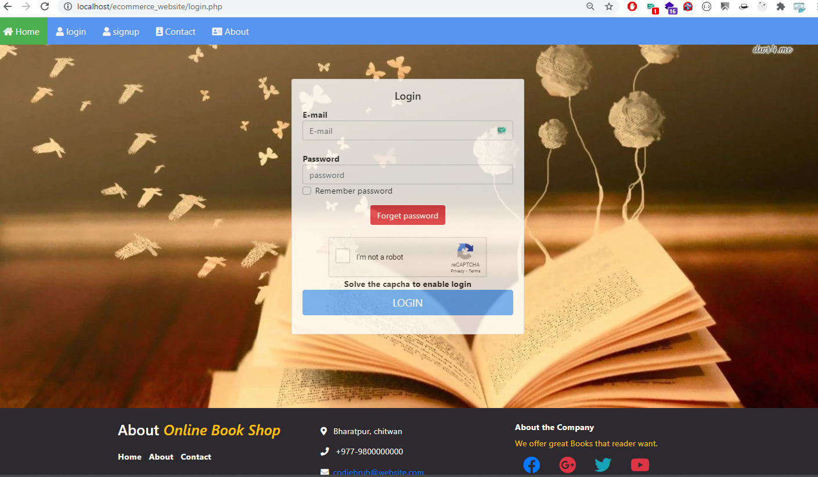

Figure 3‑20 User login Interface

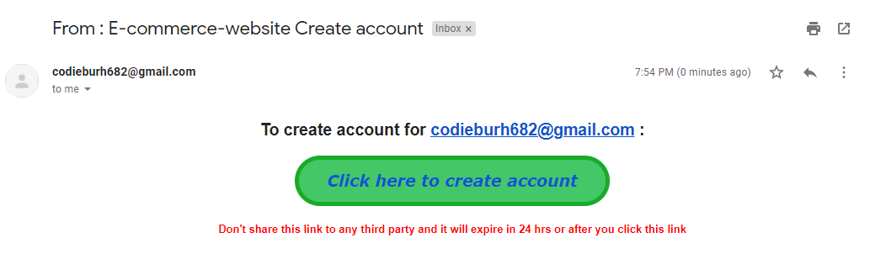

Figure 3‑21 Register Email confirmation

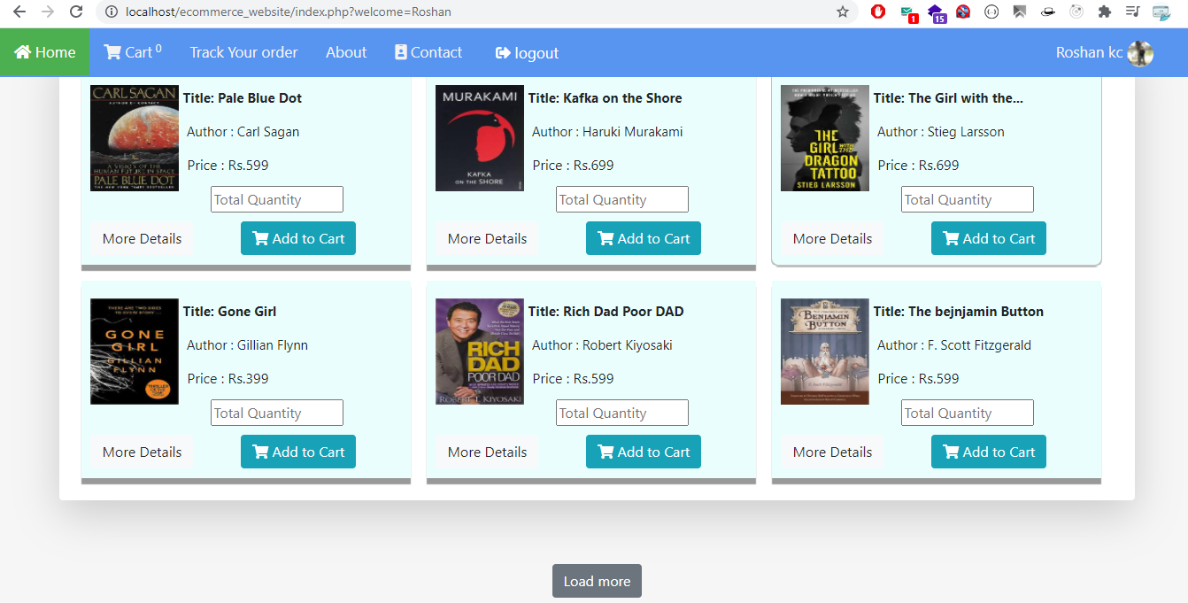

Figure 3‑22 User Interface

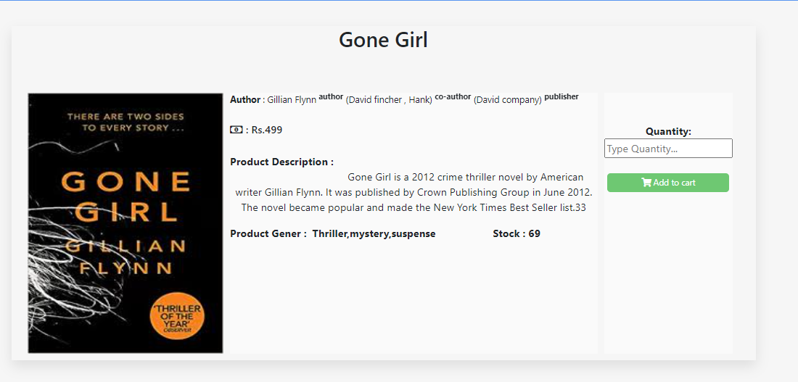

Figure 3‑23 User Interface Book Details

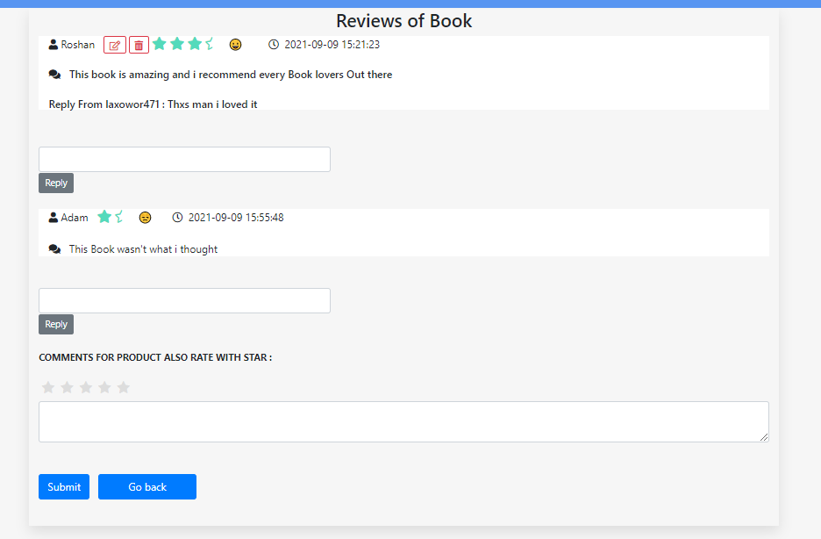

Figure 3‑24 Books Reviews





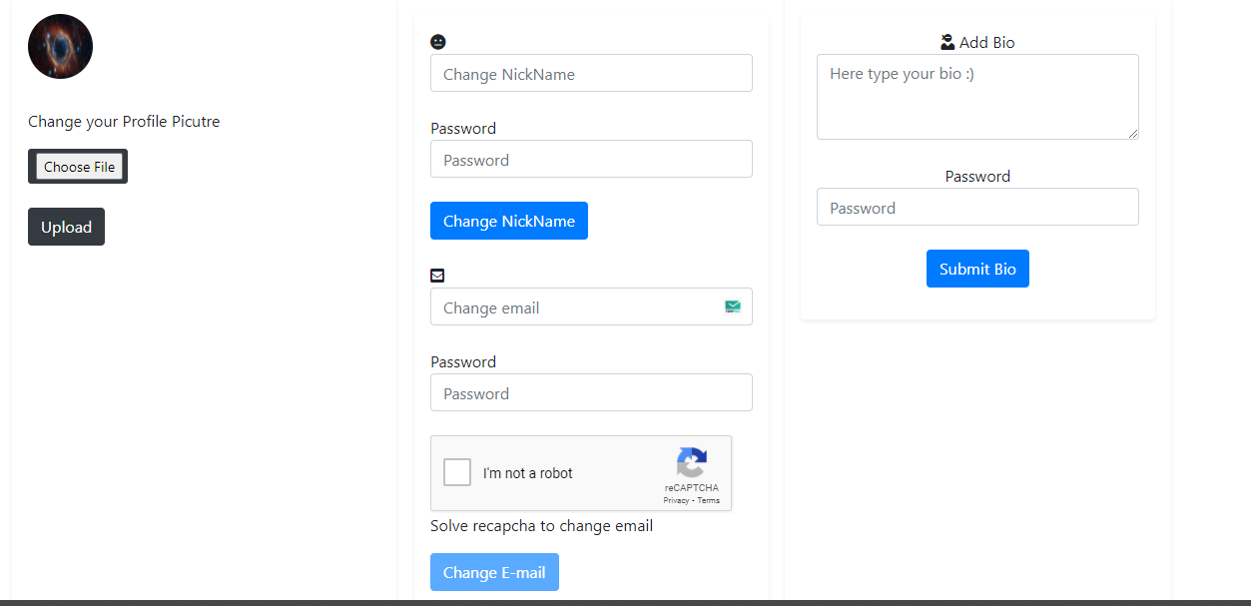

Figure 3‑25 User Dashboard

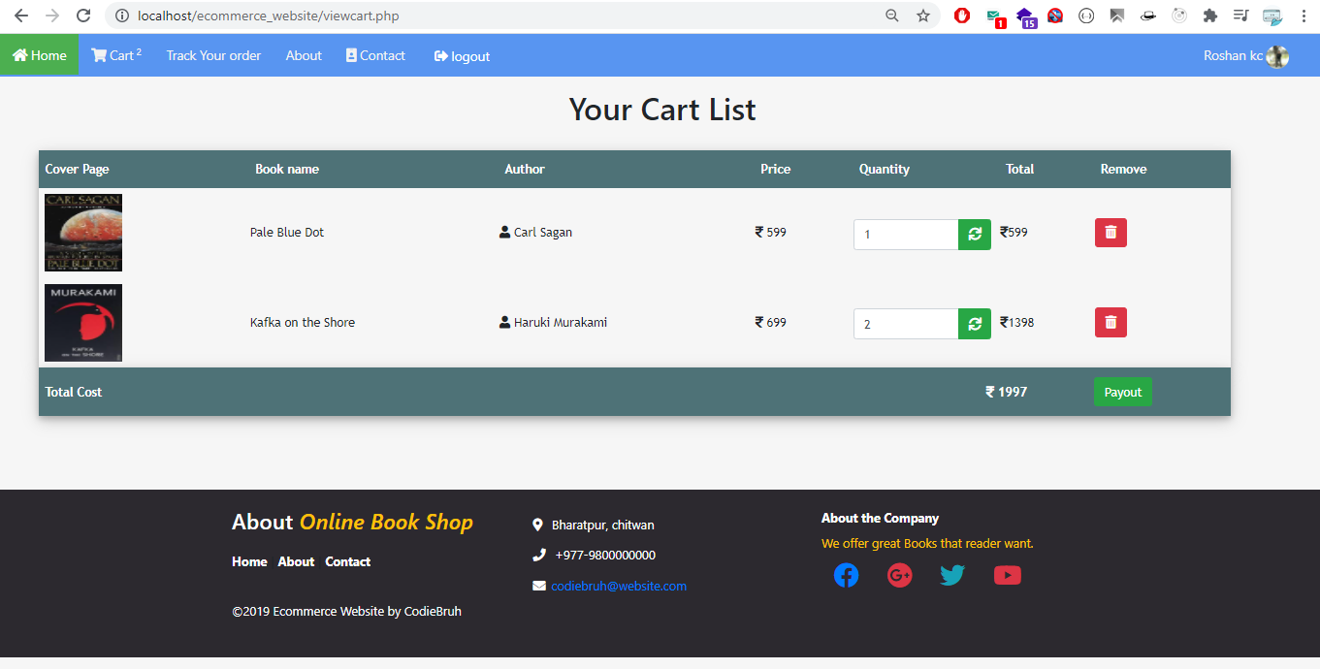

Figure 3‑26 User Cart

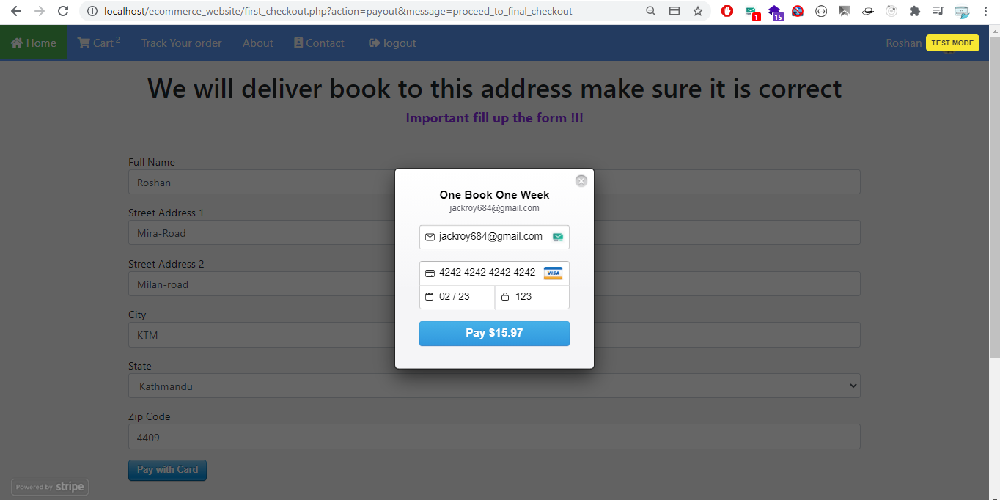

Figure 3‑27 Payout from Cart

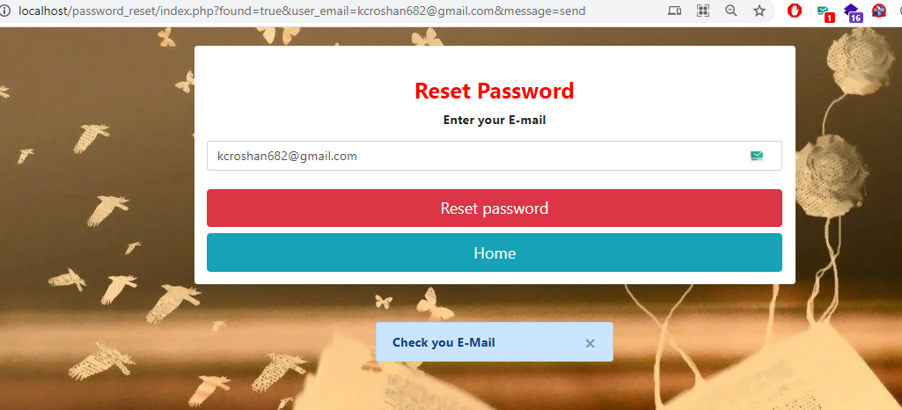

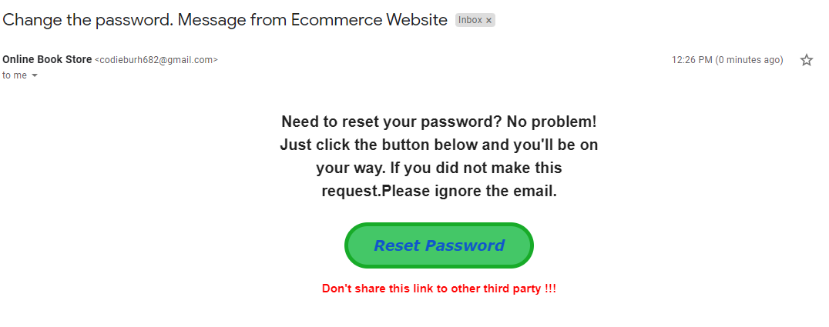

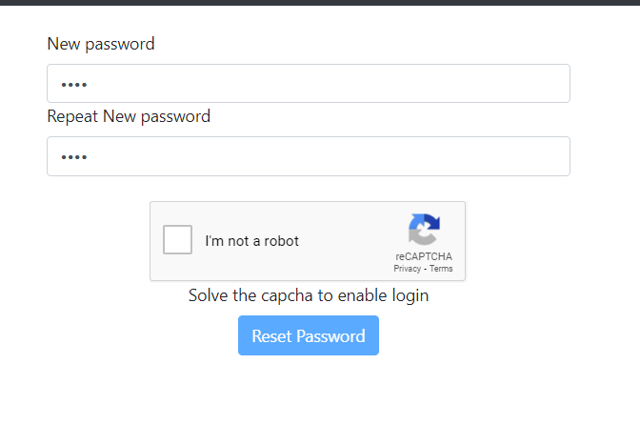

Figure 3‑28 User Reset Password

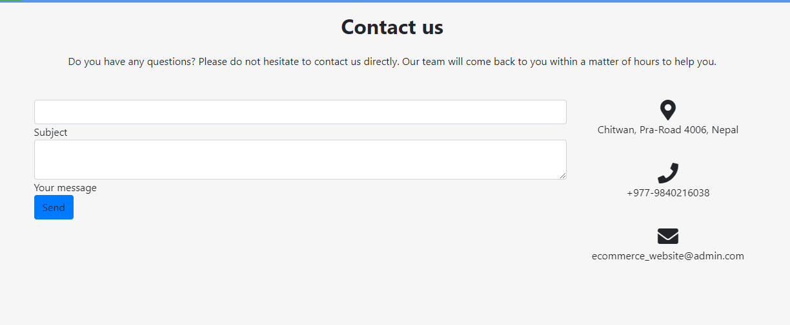

Figure 3‑29 Contact Form

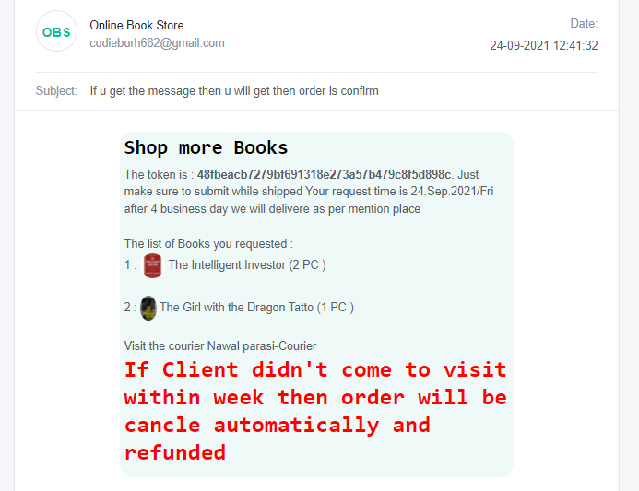

Figure 3‑30 Token Mail to User

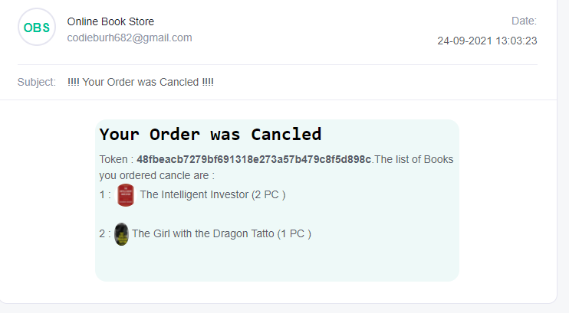

Figure 3‑31 Order Cancel

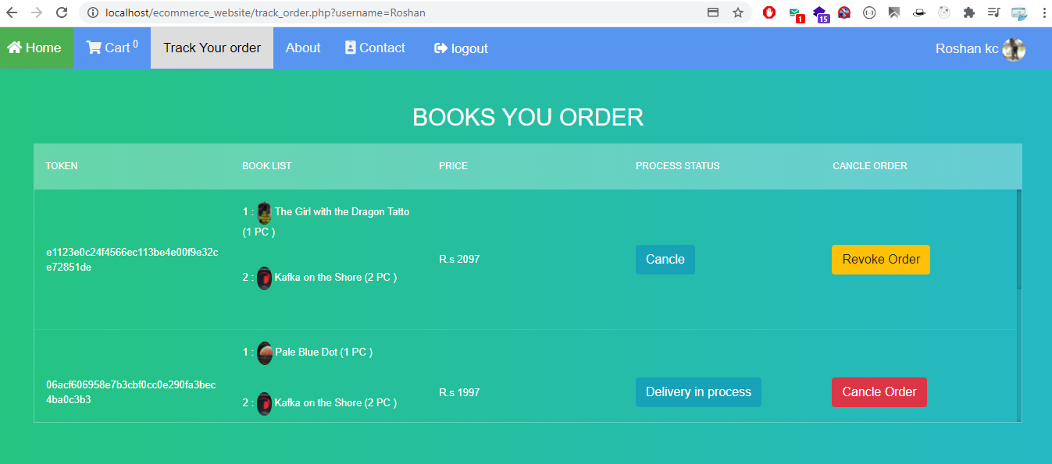

Figure 3‑32 Track-Order

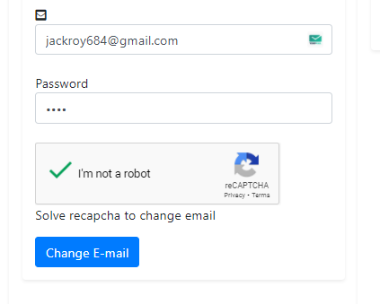

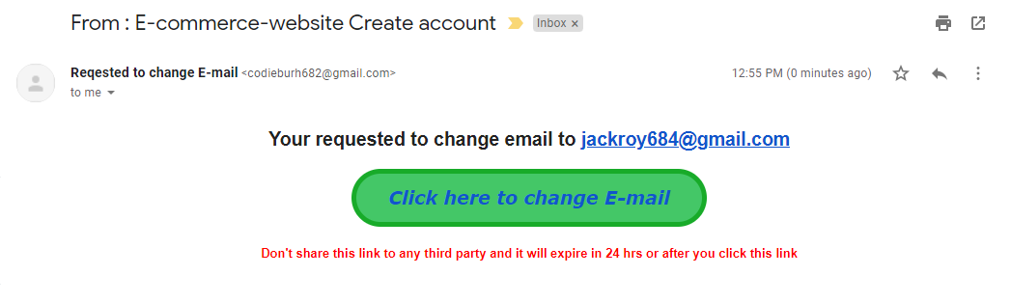

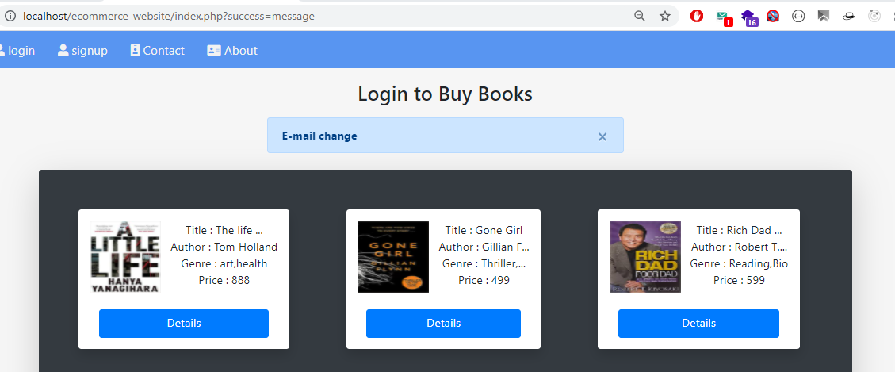

Figure 3‑33 Change E-Mail

### Physical DFD

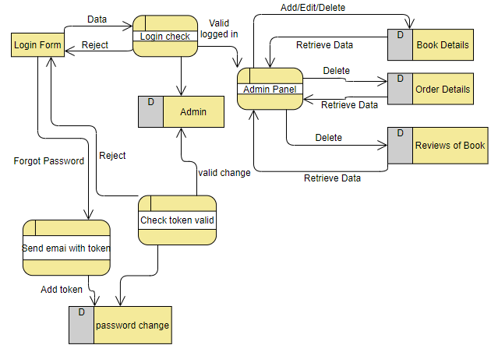

Figure 3‑34 Physical DFD – Admin Panel

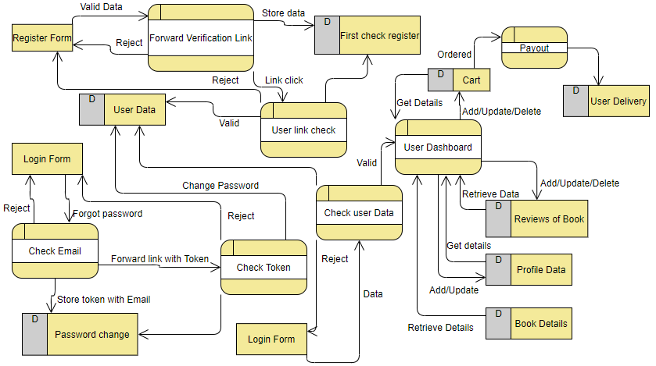

Figure 3‑35 Physical DFD-User Interaction

# Implementation and Testing

## Implementation

### Tools Used (CASE tools, Programming languages, Database platforms)

The Software development life cycle has been used as input in the implementation process. Before coding, I create ER and DFD using creatly and visual-paradigm.com online editor. The actual implementation has been done using PHP. PHP has been used to interact with the backend database. In this implementation, My SQLServer has been used as the backend RDBMS. PHP processes the inputs or commands given by the user and translates them in the commands understandable to the backend database. The output produced by the backend database is also handled by PHP which then displayed on the Browser screen.

### Implementation Details of Modules (Description of procedures/functions)

Following are all the modules designed for the Online Shopping System.

#### Admin Module

In this module only admin can have access to login and able to Add Book details. Admin can also Update, Delete products if necessary .Moreover, Admin can see the list of orders with User Details to verify to make purchase successful.

#### Shop Products Module

This module starts when the user register account with valid email and log in with verified account and visits the home page and when a user searches for a product by entering a search term. This part of the application includes displaying all the Books that are available or the Books that match the search term entered by the user. The user can then filter these Books based on various parameters like author name, title or Category. The user browse through the products and each Books would be displayed with a Cover Page and its description. A user can add a Book to the cart by clicking on Add to cart button. The user would be able to see the shopping cart summary.

#### Product Description Module

This module starts when a user visits the product description page by clicking more details button. The user can view the complete specification of the product like its Title, Description, author name, price, cover page etc. A user can also view the reviews of the Books. A user can also write a review for the Books

#### Profile Module

In this module a log in user can set his profile picture, Nickname, change password and Write a Bio of its own. Incase user forgot there password then they can reset it using email verification module

#### Payment Module

In this module the final step of payment is done after user payout from the cart all details has to be fill-up such as Location, email , name and lastly the payment is done via credit card which will be added in admin stripe account with single information miss the order will not be forwarded. Finally, user will be forwarded a Token Via a register email to identify them as client.

## Testing

Testing is a process of running with intent of finding errors in Application. Testing assures the quality of software and represents final review of other phases of software like specification, design, code generation etc. [6].

### Test Cases for Unit Testing

Unit testing emphasizes the verification effort on the smallest unit of web application design i.e. a website component or module. Unit testing is a dynamic method for verification, where code is actually compiled and executed. Unit testing is performed in parallel with the coding phase. Unit testing tests units or modules not the whole website.

I have tested each module of the website individually. As the modules were built up testing was carried out simultaneously, tracking out each and every kind of input and checking the corresponding output until module is working correctly.

The functionality of the modules was also tested as separate units. Each of the five modules was tested as separate units. In each module all the functionalities were tested in isolation.

For admin level, only admin can insert the book details after login. After adding data in database admin can able to edit if there is some error in data or can delete if it is duplicate.

For Shop Products Module when a product has been added to cart it has been made sure that if the item already exists in the shopping cart then the quantity is increased by one else a new item is created in the shopping cart.

For Product Description Module it has been tested that all the images, description, price etc. Displayed are properly. Users can add review and can reply its reviews and can Edit/Delete reviews. In the Cart Details it has been tested that when a user edits a quantity or removes product from the cart, the total price is updated accordingly.

In profile Module, user can Update his/her profile picture or not. Moreover, user can change password and can login with new password and can write a short bio.

In payment module the user has to fill-up all details like location, street, Email as register account, and valid credit card which will be later confirm by admin.

### Test Cases for System Testing

System testing is used to verify, whether the developed system meets the requirements. With minimum hardware and software requirement project i.e. dedicated server containing Debian or Ubuntu with apache with PHP and MySQL install will be sufficient for running the whole website in one go.

Unit testing for each Form

Table 4‑1 Admin login test

|  |  |  |  |  |  |  |
| --- | --- | --- | --- | --- | --- | --- |
| Test Case ID | Test Scenario | Test Steps | Test Date | Expected Results | Actual Results | Pass/Fail |
| TU01 | Check Customer Login with valid Data | 1.Go to site http://localhost/admin_test  2.Enter username  3.Enter password  4.Click Submit | Username=admin  Password=admin | Admin should be login into application | As Expected | Pass |
| TU02 | Check Customer Login with valid Data | 1.Go to site http://localhost/admin_test  2.Enter username  3.Enter password  4.Click Submit | Username=admin  Password=test | Admin should not be login into application | As Expected | Pass |

Table 4‑2 Admin Password reset via email

|  |  |  |  |  |  |  |
| --- | --- | --- | --- | --- | --- | --- |
| Test Case ID | Test Scenario | Test Steps | Test Date | Expected Results | Actual Results | Pass/Fail |
| TU03 | Check reset password for valid email and valid token | 1. After getting Email.  2. <http://localhost/admin_test/password_reset_final_with_token.php?email=admin-Email&token=valid_number> | New password=test  Repeat password=test | Password change | As Expected | Pass |
| TU04 | Check reset password for valid email and valid token | 1. After getting Email.  2. http://localhost/admin_test/password_reset_final_with_token.php?email=Valid-Email&token=invalid_number | New password=test  Repeat password=test | Password doesn’t change | As Expected | Pass |

Table 4‑3 User Password reset via email

|  |  |  |  |  |  |  |
| --- | --- | --- | --- | --- | --- | --- |
| Test Case ID | Test Scenario | Test Steps | Test Date | Expected Results | Actual Results | Pass/Fail |
| TU05 | Check reset password for valid email and valid token | 1. After getting Email.  2. <http://localhost/password_reset/reset_password_final.php?user=Valid> E-mail&token=Valid-Token  3.Solve Recapcha  4.Click Submit | New password=test  Repeat password=test | Password change | As Expected | Pass |
| TU06 | Check reset password for valid email and valid token | 1. After getting Email.  2. <http://localhost/password_reset/reset_password_final.php?user=Valid> E-mail&token=InValid-Token  3.Solve Recapcha  4.Click Submit | New password=test  Repeat password=test | Password doesn’t change | As Expected | Pass |

Table 4‑4 Insert Books Details by admin

|  |  |  |  |  |  |  |
| --- | --- | --- | --- | --- | --- | --- |
| Test Case ID | Test Scenario | Test Steps | Test Date | Expected Results | Actual Results | Pass/Fail |
| TU07 | Check to insert Book details  With valid image and title | 1.Go to site http://localhost/admin_test/insertForm.php  2.Enter title, author, co-author, publisher, price, choose image, stock and description  3.Click Submit | ISBN=ISBN-Number  Title=Mein kamf  Author=Adolf Hitler  Price = 699  Description=Book is about Adolf history  Image=cover.jpg | Application should upload | As Expected | Pass |
| TU08 | Check to insert Book details  With Invalid image and title | 1.Go to site http://localhost/admin_test/insertForm.php  2. .Enter title, author, co-author, publisher, price, choose image, stock and description  3.Click Submit | ISBN=ISBN-Number  Title=Mein kamf  Author=Adolf Hitler  Price = 699  Description=Book is about Adolf history  Image=cover.txt | Application should not upload | As Expected | Pass |

Table 4‑5 Registration of User with valid email

|  |  |  |  |  |  |  |
| --- | --- | --- | --- | --- | --- | --- |
| Test Case ID | Test Scenario | Test Steps | Test Date | Expected Results | Actual Results | Pass/Fail |
| TU09 | Check Customer Register with valid email and username | 1.Go to site http://localhost/signup_check/signup.php  2.Enter app required fields with valid email  4.Click Submit | Username=roshan  Nickname=Roshan  [Email=kcroshan682@gmail.com](mailto:Email=kcroshan682@gmail.com)  Password=test@123  Repeat Password=test@123 | User should get mail if email is valid to verify account | As Expected | Pass |
| TU10 | Check Customer Register with invalid email and username | 1.Go to site http://localhost/signup_check/signup.php  2.Enter app required fields with valid email  4.Click Submit | Username=Roshan#$  Nickname=Roshan  [Email=unavaible@gmail.com](mailto:Email=unavaible@gmail.com)  Password=test@123  Repeat Password=test@123 | User cannot login before verified | As Expected | Pass |

Table 4‑6 User login

|  |  |  |  |  |  |  |
| --- | --- | --- | --- | --- | --- | --- |
| Test Case ID | Test Scenario | Test Steps | Test Date | Expected Results | Actual Results | Pass/Fail |
| TU11 | Check Customer Login with valid Data | 1.Go to site http://localhost/ecommerce_website/login.php  2.Enter email  3.Enter password  4.Solve Recapcha  5.Click Submit | email=kcroshan682@gmail.com  Password=test@123 | Admin should be login into application | As Expected | Pass |
| TU12 | Check Customer Login with invalid Data | 1.Go to site http://localhost/ecommerce_website/login.php  2.Enter email  3.Enter password  4.Solve Recapcha  5.Click Submit | Email= kcroshan682@gmail.com  Password=invalid password | Admin should not be login into application | As Expected | Pass |

Table 4‑7 Changing E-mail

|  |  |  |  |  |  |  |
| --- | --- | --- | --- | --- | --- | --- |
| Test Case ID | Test Scenario | Test Steps | Test Date | Expected Results | Actual Results | Pass/Fail |
| TU13 | Check Customer Change Email | 1.Go to site http://localhost/ecommerce_website/setting.php  2.Enter email  3.Enter password  4. Solve recaphca  5.Click Submit | email=test@gmail.com  Password=valid-Password | Email send | As Expected | Pass |
| TU14 | Check Customer Change Email | 1.Go to site http://localhost/ecommerce_website/setting.php  2.Enter email  3.Enter password  4. Solve recaphca  5. Click Submit | Email= test@gmail.com  Password=invalid password | Email not send | As Expected | Pass |

Table 4‑8 Password change

|  |  |  |  |  |  |  |
| --- | --- | --- | --- | --- | --- | --- |
| Test Case ID | Test Scenario | Test Steps | Test Date | Expected Results | Actual Results | Pass/Fail |
| TU15 | Check Customer Change password | 1. Go to site http://localhost/ecommerce_website/setting.php  2. Enter Current password and new password.  3. Click Submit | Password=valid-Password  New Password=New password | Change password | As Expected | Pass |
| TU16 | Check Customer Change password | 1. Go to site http://localhost/ecommerce_website/setting.php  2. Enter Current password and new password.  3. Click Submit | Password=valid-Password  New Password=New password | Current password not valid message | As Expected | Pass |

Table 4‑9 Add Bio by user

|  |  |  |  |  |  |  |
| --- | --- | --- | --- | --- | --- | --- |
| Test Case ID | Test Scenario | Test Steps | Test Date | Expected Results | Actual Results | Pass/Fail |
| TU17 | Check Customer update Bio | 1.Go to site http://localhost/ecommerce_website/setting.php  2. Enter Current password and new password.  3.Click Submit | Bio=Bio details  Password=password | Update Bio | As Expected | Pass |
| TU18 | Check Customer update Bio | 1.Go to site http://localhost/ecommerce_website/setting.php  2. Enter Current password and new password.  3.Click Submit | Bio=Bio details  Password=Invalid password | Message doesn’t match | As Expected | Pass |

Table 4‑10 Add to cart

|  |  |  |  |  |  |  |
| --- | --- | --- | --- | --- | --- | --- |
| Test Case ID | Test Scenario | Test Steps | Test Date | Expected Results | Actual Results | Pass/Fail |
| TU19 | Check Customer add quantity in cart | 1.Go to site http://localhost/ecommerce_website/details_of_product.php?passed_id=234234333  2. Enter quantity.  3.Click Submit | Quantity = Stock remaining valid | Update Cart | As Expected | Pass |
| TU19 | Check Customer add quantity in cart | 1.Go to site http://localhost/ecommerce_website/details_of_product.php?passed_id=234234333  2. Enter quantity.  3.Click Submit | Quantity = Stock remaining invalid | Message Quantity high | As Expected | Pass |

Table 4‑11 Reviews of product after login

|  |  |  |  |  |  |  |
| --- | --- | --- | --- | --- | --- | --- |
| Test Case ID | Test Scenario | Test Steps | Test Date | Expected Results | Actual Results | Pass/Fail |
| TU20 | Check Customer add review of books | 1.Go to site http://localhost/ecommerce_website/details_of_product.php?passed_id=book_id  2. Enter Review and rate star.  3.Click Submit | Reviews = Valid character | Update Reviews | As Expected | Pass |
| TU21 | Check Customer add review of books | 1.Go to site http://localhost/ecommerce_website/details_of_product.php?passed_id= book_id  2. Enter Review and rate star.  3.Click Submit | Reviews = Null | Message cannot be zero character | As Expected | Pass |

Table 4‑12 User Payment

|  |  |  |  |  |  |  |
| --- | --- | --- | --- | --- | --- | --- |
| Test Case ID | Test Scenario | Test Steps | Test Date | Expected Results | Actual Results | Pass/Fail |
| TU21 | Check customer with valid credit card and details | 1.Go to site http://localhost/ecommerce_website/first_checkout.php  2.Enter Details  3.Enter pay with card and checkout  4.Click Pay | Full Name=Roshan kc  Street=road-12  City=Kathmandu  Zip Code=4406  E-mail=kcroshan682@gmail.com  Card Number=424242424242 | User should get E-mail | As Expected | Pass |
| TU22 | Check customer with invalid credit card and details | 1.Go to site http://localhost/ecommerce_website/first_checkout.php  2.Enter invalid email  3.Enter pay with invalid card and checkout  4.Click Pay | Full Name=Roshan kc  Street=road-12  City=Kathmandu  Zip Code=4406  E-mail= unavaible@gmail.com  Card Number=0000000000 | User should not get E-mail | As Expected | Pass |

# Conclusion and Future Recommendations

## Lesson Learnt / Outcome

The application can be used for any Books store. It is easy to use, since it uses the GUI provided. User friendly screens are provided. The website is easy to use and interactive making online shopping a recreational activity for users. It has been thoroughly tested and implemented.

Moreover, the website makes me firmly believe that I can develop other ecommerce website using simple html, CSS and PHP with MySQL database. The requirement for this kind of implementation is minimum and the setup is easy.

On the other hand, there could be some issue with the page. If user do some changes then whole page has to reload to see changes which make the speed of website delay.

## Conclusion

The ‘Online Book store’ is designed to provide a web based application that would make searching, viewing and selection of a product easier. The user can then view the complete specification of each product. They can also view the product reviews and also write their own reviews.

The user can then view the complete specification of each product. They can also view the product reviews and also write their own reviews.

However, after implementing the application it will contain the advantages were incomparable to the present contemporary systems used by company. The most admirable feature founded was its simplicity in terms of application to the user but its highly beneficial outputs can’t be ignored which was gained in short period of time.

Mull over, the users will be highly benefited after using the system. It is hoped that this project will help the future developers to modify and implement the system. After modifying some techniques of the programs, it will give us the best performance as our requirements. The project will be very useful for the users

## Future Recommendations

Software building is never ending process and continues the life of the software as per the changing needs of the user from time to time. The project is no doubt has been developed keeping in mind easy modification and enhancement that may be required from time to time. However, there are many scopes to modify this software. As because due to shortage of time, I become unable to include many things. The following scope can be added in future, the users could subscribe for price alerts which would enable them to receive messages when price for products fall below a particular level, users can have multiple shipping and billing information saved. During checkout they can use the drag and drop feature to select shipping and billing information.

References

|  |  |
| --- | --- |
| [1] | S. Ramunam, "document/280494," 2018. [Online]. Available: https://www.grin.com/. |
| [2] | libguides.com, "c.php?g=34942&p=222060," 20 4 2020. [Online]. Available: https://laverne.libguides.com/. |
| [3] | Guru99, "functional-vs-non-functional-requirements.html," 12 6 2020. [Online]. Available: https://www.guru99.com/. |
| [4] | S. Jena, "types-of-feasibility-study-in-software-project-development/," 2021. [Online]. Available: https://www.geeksforgeeks.org/. |
| [5] | indiatimes.com, "definition/systems-design," 2018. [Online]. Available: https://economictimes.indiatimes.com/. |
| [6] | en.wikipedia.org, "wiki/Software_testing," 23 4 2021. [Online]. Available: https://en.wikipedia.org/. |